**Environment Setup Instructions**

**Anaconda (Python 3.7)**

**Download -**

[**https://www.anaconda.com/download/**](https://www.anaconda.com/download/)

**Install in D drive as it may take up space.**

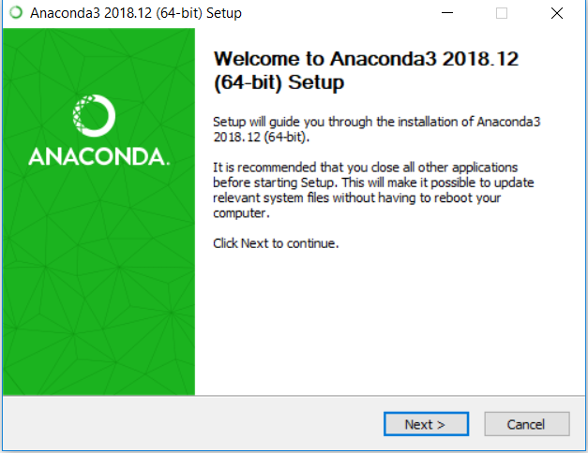

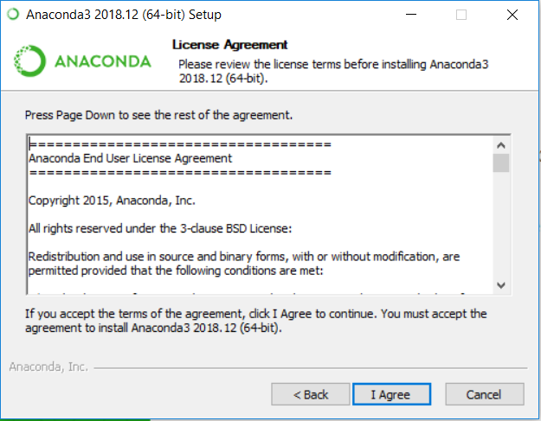

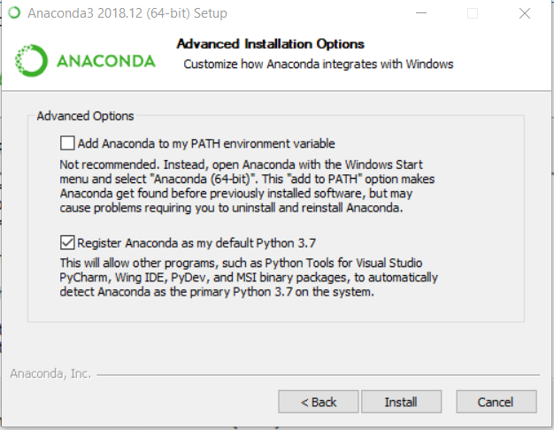

**Create Python 3.6 environment.**

Environmentts -> Create

Name it py36 and select Python version 3.6

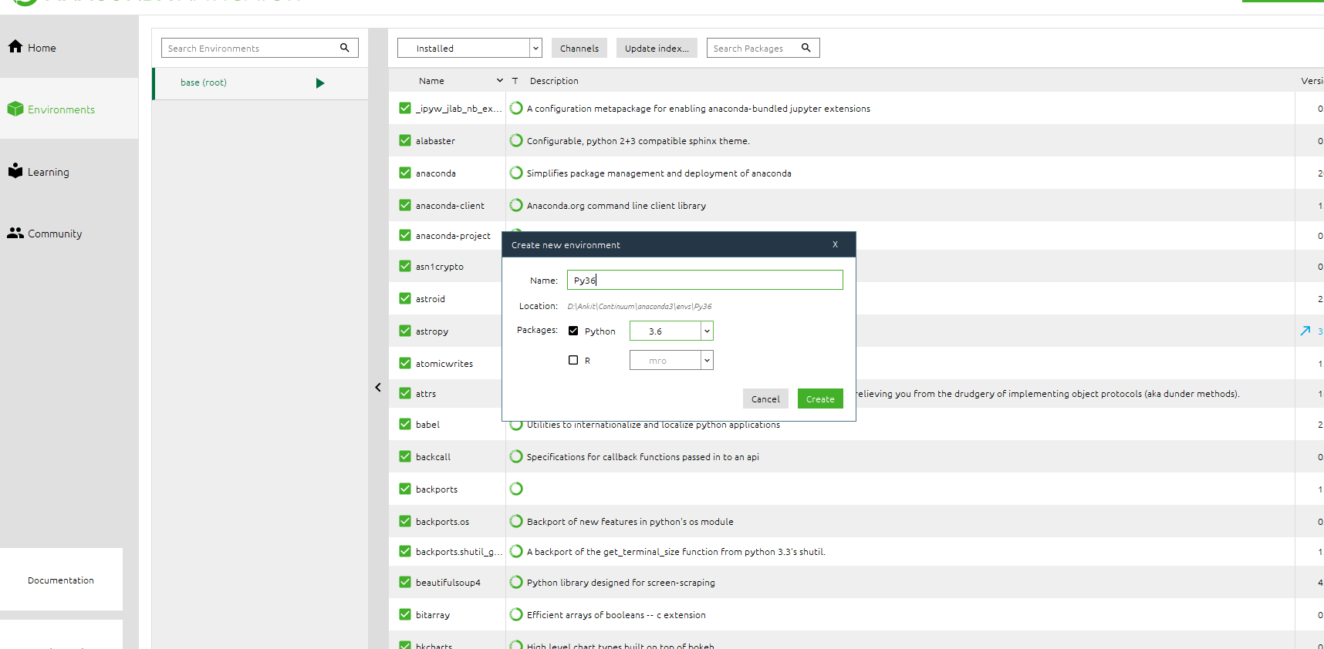

**Search and install packages**

**TensorFlow:**

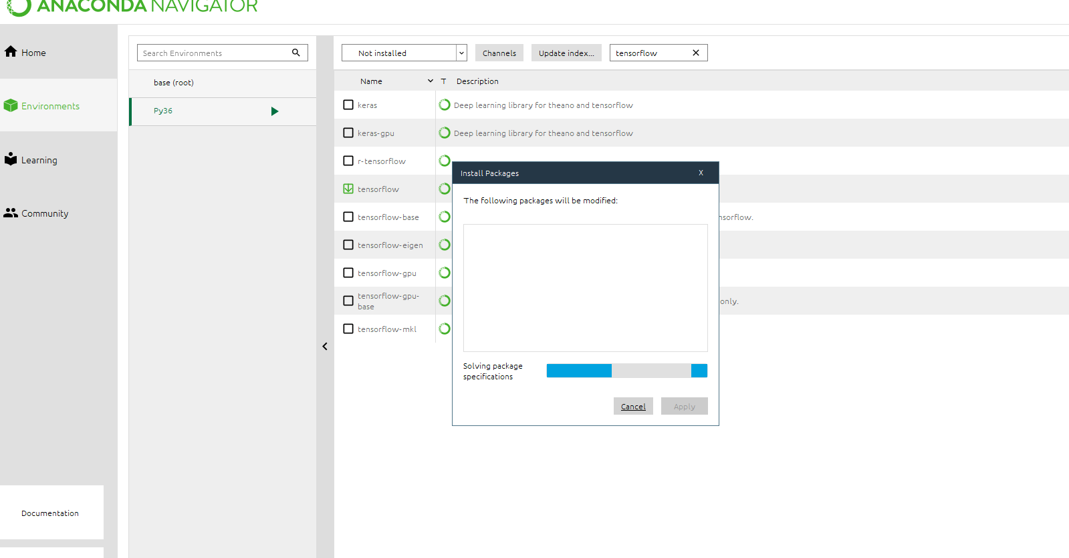

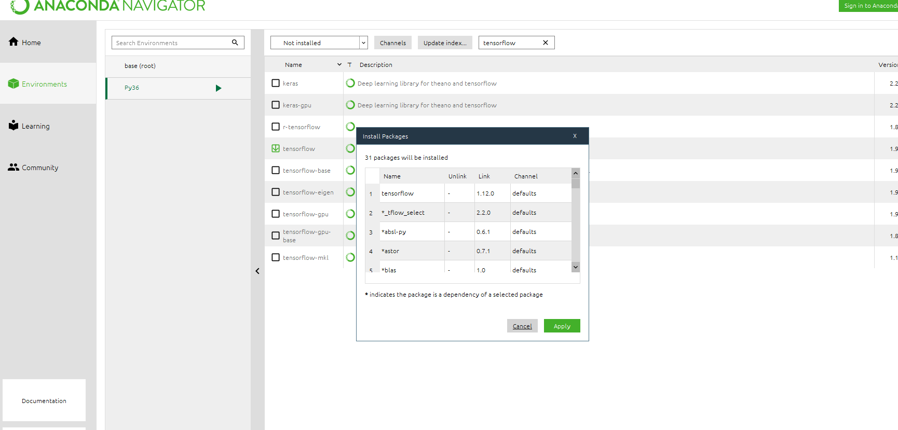

**Keras:**

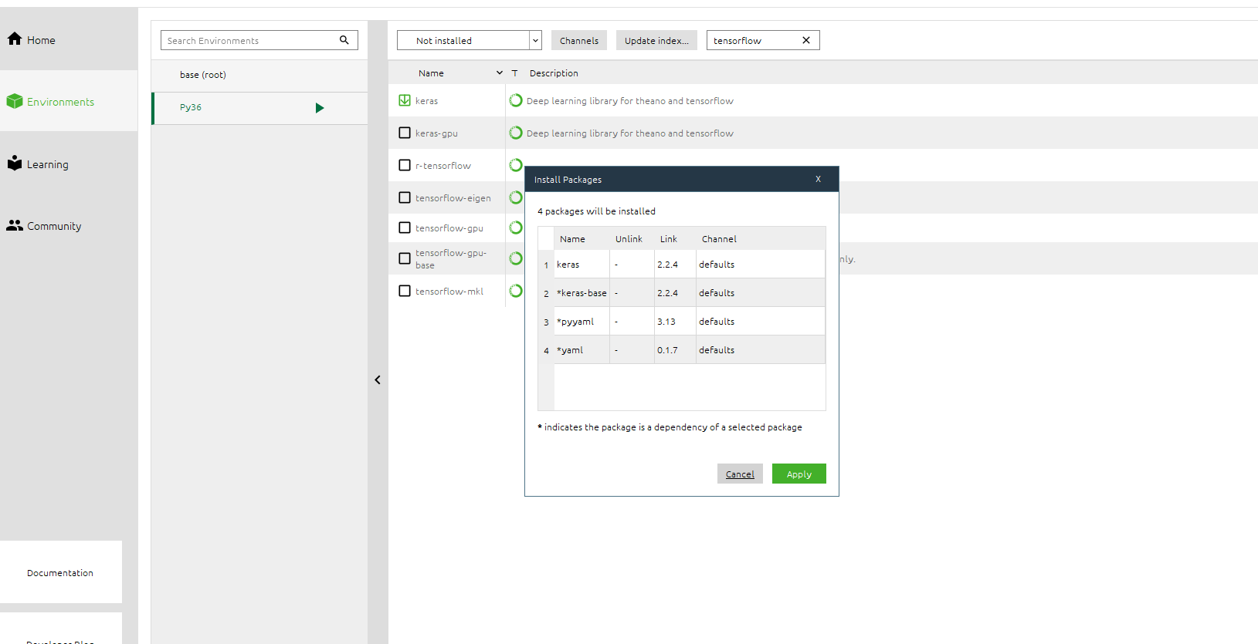

**Snowballstemmer**

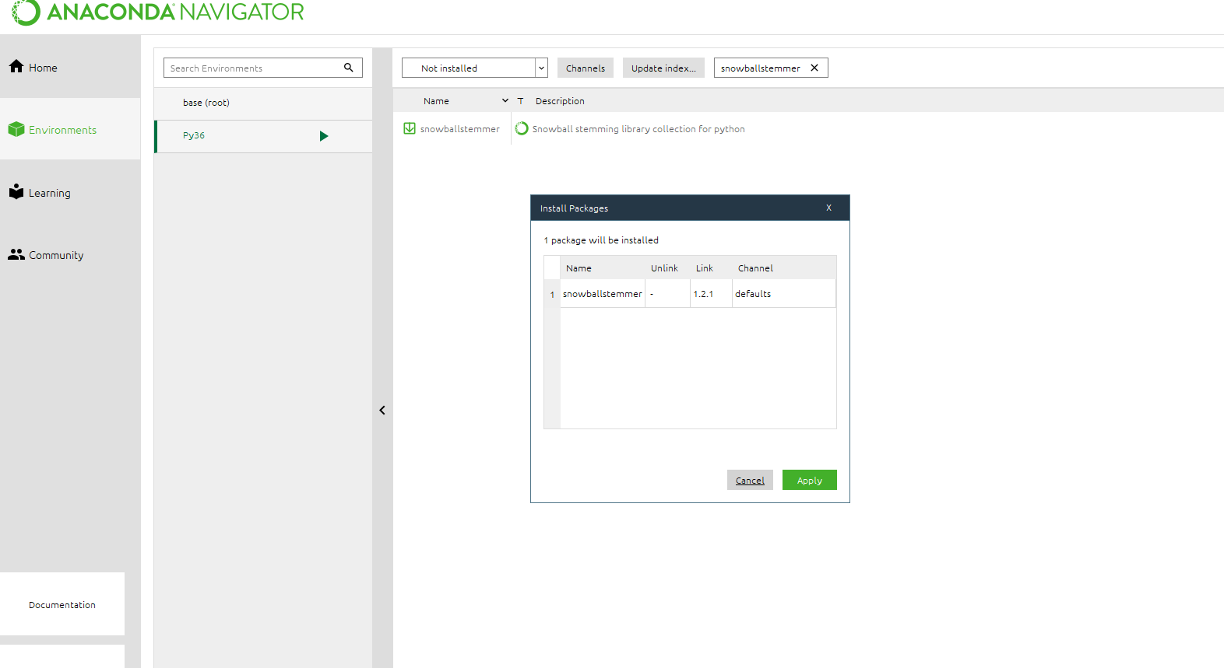

**Install Jupyter Notebook in the py36 environment**

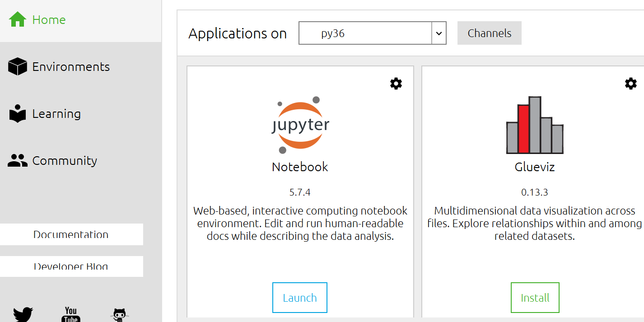

Launch Jupyter notebook

